To Your Table Fall 2014
Meal Instructions week 7
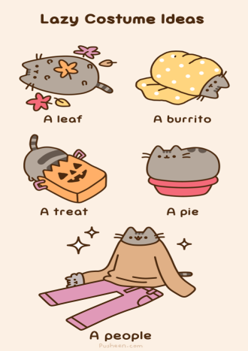
HOLIDAY NEWS

First Slice is now accepting Thanksgiving orders!
Don’t miss out…
Order before Nov. 15th and receive a free small Glogg Cake!
COOKING INSTRUCTIONS (Cooking times may vary)
40 Cloves Garlic Chicken
Keep frozen. Preheat oven to 350 degrees, remove lid and place on a sheet tray. Bake for 40 minutes.
Traditional Meat Lasagna
Keep Frozen. Preheat oven to 375 degrees. Remove lid & place on a baking sheet. Bake for 40-45 minutes. The middle should be hot. OR Thaw First and bake for 30 mins.
Wild Rice & Duck & Apple Strudel Keep Frozen, Preheat oven to 350 degrees. Remove lid and place on sheet tray. Cook for 35-40 minutes.
Friday Night Fish Fry & Basil Tartar
Keep frozen. Preheat oven to 350 ˚. Place Tilapia on sheet tray and bake for 30 mins. Bake an additional 5 mins if needed. Middle should be hot. Serve with basil tartar sauce.
Eggplant Parmesan
Keep frozen. Remove plastic lid & bake in oven at 350° for 35 mins.
Veggie & Phoenix Bean Tofu Stir Fry
Heat sauce in sauté pan. toss with vegetables & tofu for 7 minutes. Covering pan helps steam veggies. Mix well.
SIDESVILLE
Mushroom Bisque
Thaw. Heat soup in a pot. Add ½ cup of water. Simmer for 5 Min. Or open lid slightly and microwave for 8 mins. Stir and heat further if necessary.
Fresh Fruit Mick Klug Asian Pears
Spinach Salad with Honey Mustard Vinaigrette
Fresh Broccolini with Basil Butter Wash. Bring 3 cups of water and 1 tsp salt to a boil. Add Broccolini for 2-3 mins. Drain. Heat garlic Basil in a pan and sauté for 50 secs.
Tri-Color Pasta & Sundried Tomato Basil Oil Bring 4 cups water to a boil; add pasta & cook for 10 minutes. Drain. In sauté pan, heat pesto over medium heat. Toss drained pasta with oil.

Roasted Red Potatoes Keep Frozen. Preheat oven to 350 degrees. Remove the lid. Cover with foil (optional).Place on sheet tray and bake for 35 minutes.
Occu-Pie
Keep Frozen. Sharing is caring. Thaw for approx. 15 mins before consuming.

